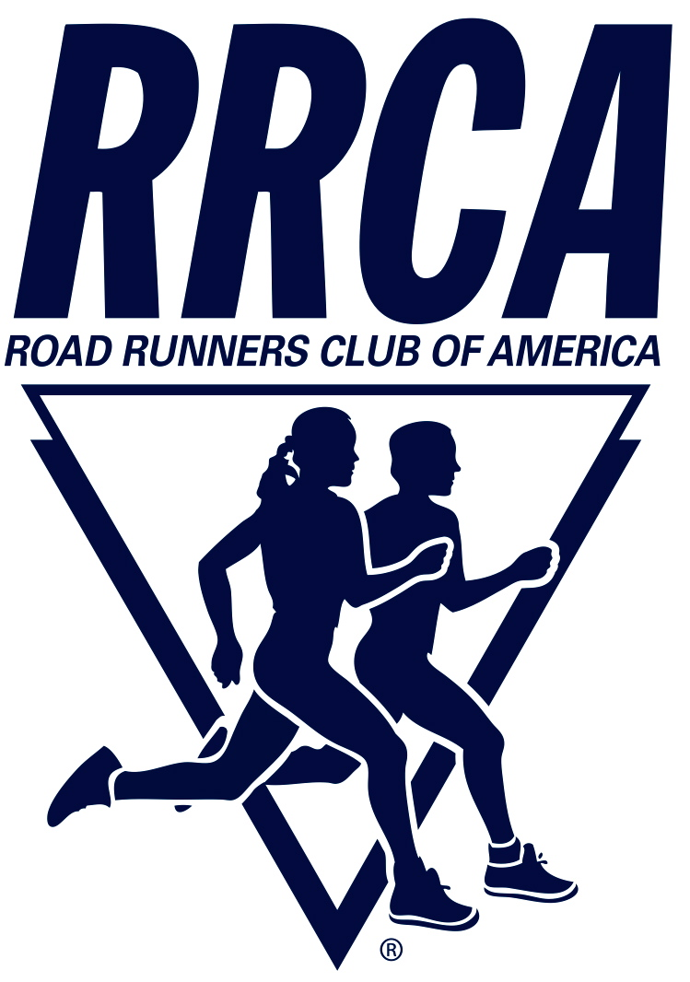
ROAD RUNNERS CLUB OF AMERICA
1501 Lee Hwy, Ste 140 : Arlington, VA 22209 : 703.525.3890
Doug Pitchford 847.502.8807 Mysol2@aol.com

December 16, 2022

Sharon Marston, Race Director
This Run's For Jack 5k
Glen Ellyn, IL

Dear Sharon,

This letter is to formally award the 2023 RRCA Illinois Championship to the This Run's For Jack 5k scheduled for October 15, 2023.

On the Championship Events section of the RRCA website, there is a subsection entitled “Branding Your RRCA Championship Event” https://www.rrca.org/programs/championships/ I encourage you to review this information as soon as possible. It contains instructions and ideas for promoting your championship designation.

Please include the RRCA Championship logo whenever possible i.e., on your race brochures, shirts and awards. A copy of the logo can be found at https://www.rrca.org/wp-content/uploads/RRCA-Championship-Logo.png. Your race should be advertised as the RRCA Illinois State 5k Championship and this phrase should be included on your awards, numbers, t-shirts and all publicity including race results. Please ensure your newsletter editor, marketing person, and web-master is aware of the foregoing publicity expectations.

On the Championship Event section of the website https://www.rrca.org/programs/championships/ you will also find detailed information about the sponsorship opportunities for events that receive the championship designation. As part of your application, you indicated your desire to receive awards, bibs, and Gatorade (if your race’s distance and size qualify). If you’d like to amend those requests, please email programs@rrca.org immediately.

There are no royalty fees for RRCA State Championship events, however if profits from the event permit, a small donation to the RRCA Annual Fund, Kids Run the Nation Fund, or RunPro Roads Scholars Fund is greatly appreciated. https://www.rrca.org/donate-to-rrca/

Thanks so much for your participation in the RRCA Championship event series and good luck with your championship race on (date).
Sincerely,

Doug Pitchford
Illinois RRCA State Rep.

